**Elevate Your Canine Companion: The Power of Professional Board and Train Programs Across the USA**

In today's fast-paced world, many dog owners seek effective and efficient ways to train their beloved companions. Enter the realm of professional [**board and train san marcos**](https://iqk9training.com/board-and-train/), a comprehensive and transformative approach to dog training that has gained widespread popularity across the United States. In this article, we will explore the advantages and impact of professional board and train programs, highlighting their benefits, methodologies, and why they have become a go-to choice for dog owners seeking remarkable results.



**The Evolution of Board and Train Programs**

Professional board and train programs have evolved beyond traditional training methods. These programs provide a unique opportunity for dogs to stay at specialized facilities under the guidance of skilled trainers. While there, dogs undergo intensive training sessions, behavior modification, and socialization exercises that contribute to their overall development.

**Key Benefits of Professional Board and Train Programs**

**1. Intensive Training:** Board and train programs offer concentrated training sessions that accelerate the learning process, resulting in faster and more effective results compared to traditional training methods.

**2. Behavior Modification:** Experienced trainers address various behavioral challenges, including anxiety, aggression, and excessive barking, employing personalized techniques to modify undesirable behaviors.

**3. Obedience Mastery:** Dogs in board and train programs master essential commands like sit, stay, recall, and leash manners. This level of obedience promotes better communication and safety between dogs and their owners.

**4. Socialization:** Dogs interact with other dogs and humans in a controlled environment, fostering confidence, reducing fear, and encouraging appropriate social behaviors.

**5. Bond Strengthening:** The immersive training experience creates a stronger bond between dogs and their owners. The positive reinforcement methods used by trainers build trust, understanding, and a deeper connection.



**Methodologies and Techniques**

Professional [**Board and Train Encinita**](https://iqk9training.com/board-and-train/) across the USA employ a range of effective training methodologies. One prominent approach is positive reinforcement, where desired behaviors are rewarded with treats, praise, or playtime. This method encourages dogs to choose positive behaviors while building trust and enthusiasm for training. Trainers also customize training plans based on individual dogs' temperaments, ensuring a tailored and effective learning experience.

The Role of Skilled Trainers

Skilled trainers play a crucial role in the success of board and train programs. These professionals possess a deep understanding of canine behavior, psychology, and training techniques. They conduct thorough assessments to create personalized training plans, closely monitor progress, and adjust strategies as needed. Importantly, they also educate dog owners on effective training methods, ensuring a seamless transition from the program to the home environment.

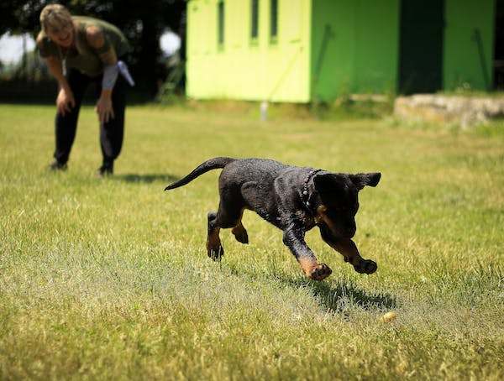

**Conclusion**

Professional board and train programs have revolutionized the world of dog training across the USA. Through intensive training, behavior modification, socialization, and positive reinforcement, these programs offer a holistic approach to transforming dogs into well-mannered and obedient companions. The expertise of skilled trainers, coupled with immersive training experiences, strengthens the bond between dogs and their owners while fostering a lifetime of positive behaviors.

For dog owners seeking remarkable results and a harmonious partnership with their four-legged friends, professional [**dog training Oceanside ca**](https://iqk9training.com/dog-and-puppy-training-in-oceanside/) provide a transformative pathway to success. In a world where time is precious and outcomes matter, these programs stand as a testament to the dedication, innovation, and commitment to canine well-being that define the modern approach to dog training in the USA.

[dog obedience training oceanside ca](https://iqk9training.com/dog-and-puppy-training-in-oceanside/) | [Puppy Training Oceanside](https://iqk9training.com/dog-and-puppy-training-in-oceanside/) | [Board and Train Poway](https://iqk9training.com/board-and-train/)